ANIMAL TAKEOVER
Studio Art 2
One of the fun things about art is that you can create whatever you want; often this leads to whimsical ideas that are impossible in real life.
For this project you are going to examine the idea of “scale”, or the proportions of the environment in comparison to objects in that environment. When something is “to scale”, that means the proportions are accurate. When something is “not to scale” it means that at least one area or object is out of proportion.
In this artwork, you are going to choose an animal and make it larger than what it normally is. So the animal is not to scale with the environment. You can make this funny, scary. . .whatever mood you want to create. As you look at the examples below you’ll see a lot of artists’ different approaches to this idea. And again, you can use any materials you want to create this.
TIPS FOR SUCCESS:
- Make it realistic. That means you will need to use photo references for the animal AND the environment you choose. No making up what something looks like out of your head. You may use more than one reference for the environment or the animal if you need to.
- Make it detailed.
- If you are drawing with pencil, you must shade the entire work and use a full value scale.
- Your artwork must fill the entire 9”x12” space.

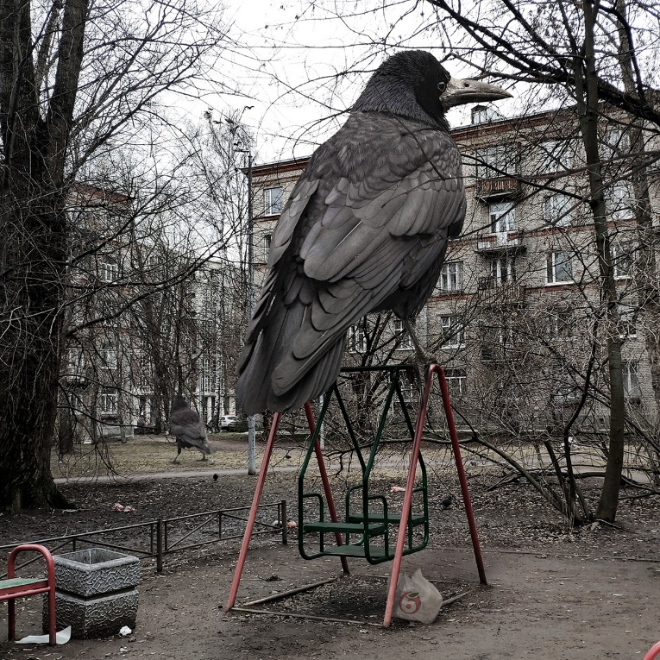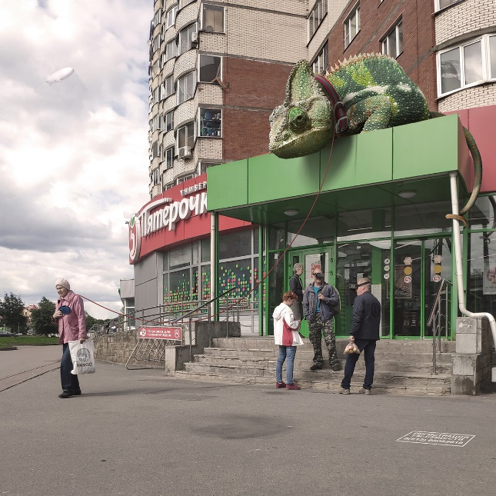
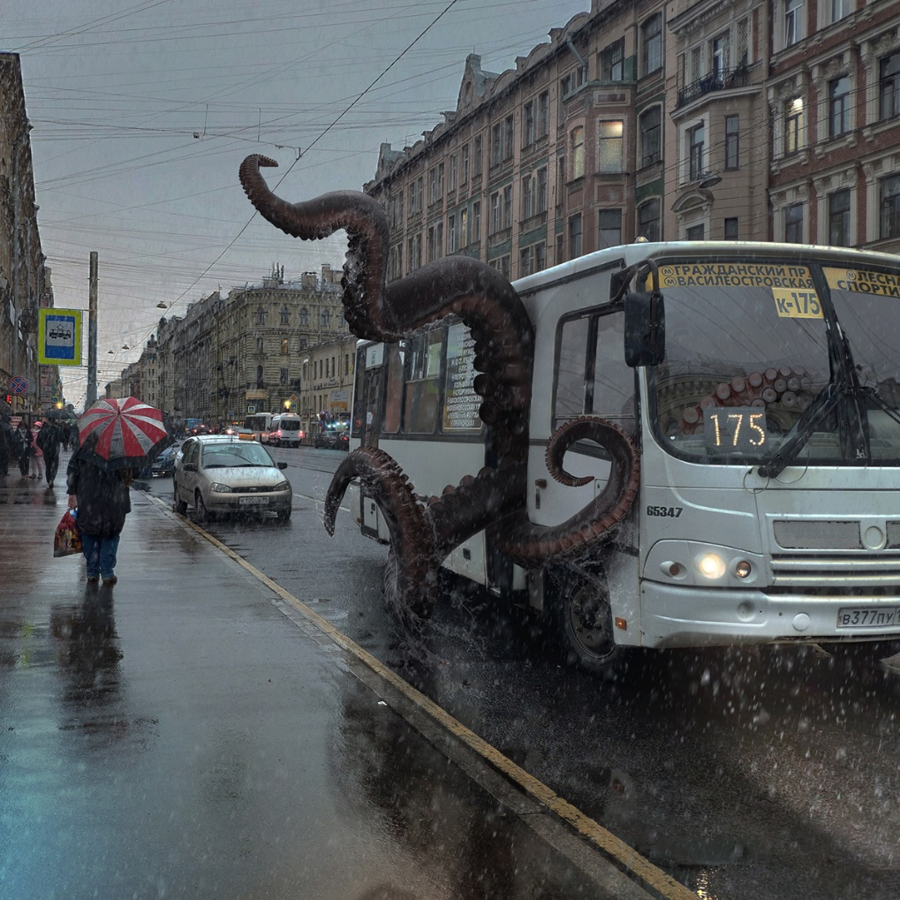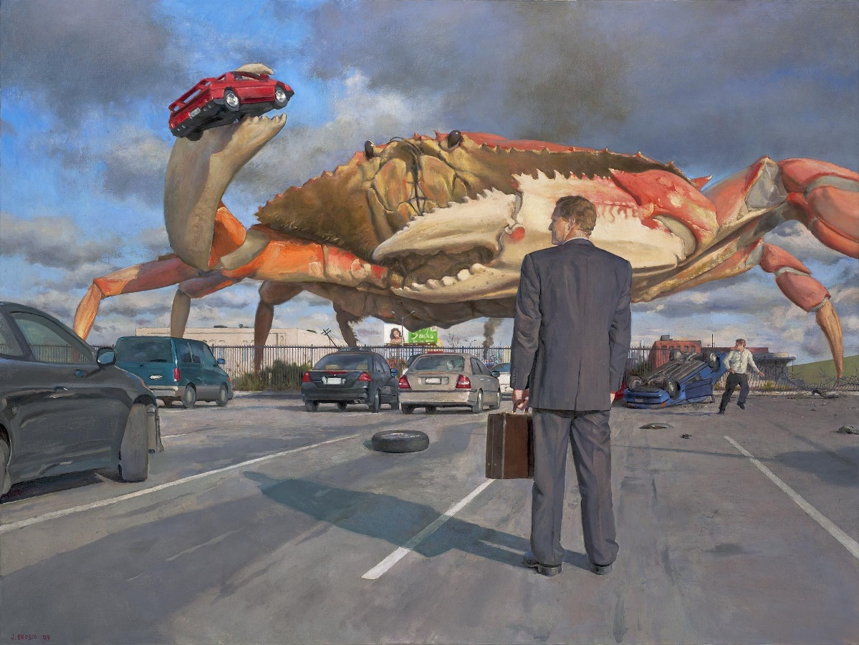
DUE DATE: FRIDAY, MAY 22, 11:59 PM

