CRUSHED CAN CHALLENGE
Studio Art 1
This drawing will be the last one we do that focuses on shading and value. Although it “looks” easy, it is much more challenging than the others because you will need to constantly look at the shapes made from the object and carefully shade from dark to light.
Take any aluminum can and crush it. From the examples below you’ll see varying degrees of how crushed the can is, and as the artist that choice is totally up to you. Try to sit somewhere near a strong light source—that could be a window or a lamp that is shining directly on the crushed can.
Looking carefully at the crushed can, you are going to lightly draw the outline as realistically as possible. Then you are going to go back and add value so that the crushed can looks as 3D as possible. The can that you draw must be larger than the original can, so it must touch at least 3 sides of the paper.
TIPS FOR SUCCESS:
- Make sure you have a full value scale. What that means is that some areas of the paper are pitch black, some areas are varying degrees of gray, and some areas are very light gray. If you shade too lightly and never get the dark gray areas in, your artwork will not look 3D at all.
- To achieve a smoother texture for the can, make sure your pencil marks are very short and close together. Shade slowly. If you make fast, sketchy marks with the pencil it will look messy.
- Draw large! Remember, it must touch at least 3 sides of the paper.
- Try to be as accurate as possible. That means spend at least 50% of the time looking at what you are drawing and 50% of the time looking at your paper. If you spend too much of your time looking at the paper and not the object it will not look like a crushed can at all. We want this to look realistic.
- The background of this drawing does not need to be shaded; however, if you see a shadow that the can casts on the surface area you need to include it.
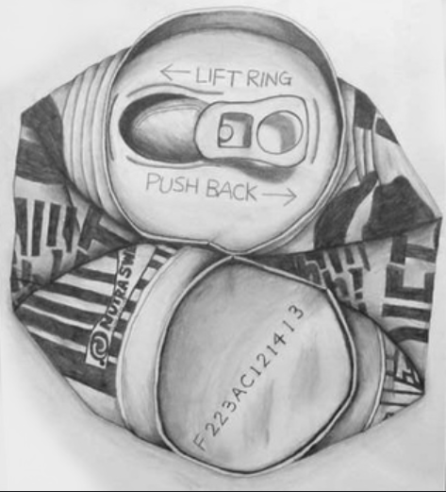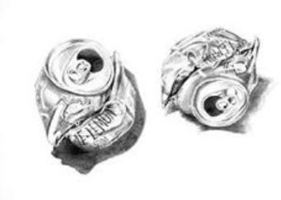
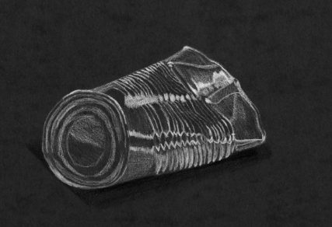
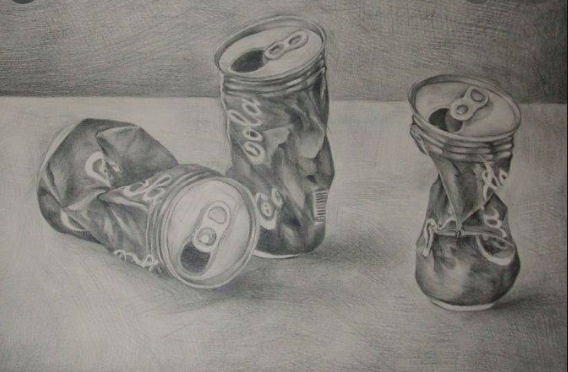

DUE DATE: TUESDAY, MAY 19, 11:59 PM

