FINAL PORTRAIT
Studio Art 1

The reason we’ve been doing all of these practice exercises with drawing facial features is because it helps to prepare you for the final project—drawing yourself!
Now don’t panic; it’s common to have a lot of insecurities about how you look and not like certain facial features, etc. Trust me, when you’re 40 years old you’re going to look at photos of when you were younger and think, “Wow, I looked great!” And as an artist, you want to push past that fear and self-criticism and examine your facial features more like a scientist. It’s hard not to feel emotional when you look in the mirror, but try your best to be detached and analytical about it.
So how do you get started? You can either use a large mirror—like in your bathroom, or a smaller mirror that you can set up and it won’t move on you. Draw from real life, not photos of yourself. This drawing should take a couple days to complete—so do not try to do it all in one day.
A portrait traditionally is from the shoulders to the top of your head, so include that in your drawing. The top of your head should touch the top of the paper and your shoulders should be drawn going off the sides of the paper towards the bottom.
REVIEW YOUR SKETCHES ON FACIAL PROPORTIONS! If you need to watch some of the videos again, do it. I can’t stress this enough. Often I have students who forget everything they’ve been taught and turn in a portrait that shows they didn’t learn anything from all the drawing exercises they did. If you’re struggling with something, often a Google search or YouTube search starting with “How to draw …” can help you get to where you want to be with your drawing.
Remember to shade and use a complete value scale. The examples below use a lot of shading—especially in the hair.
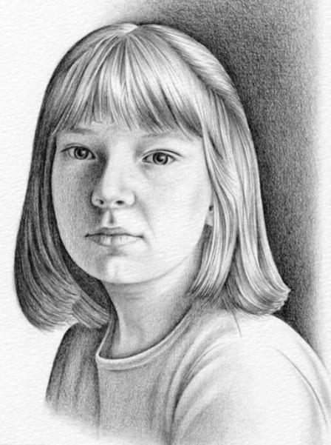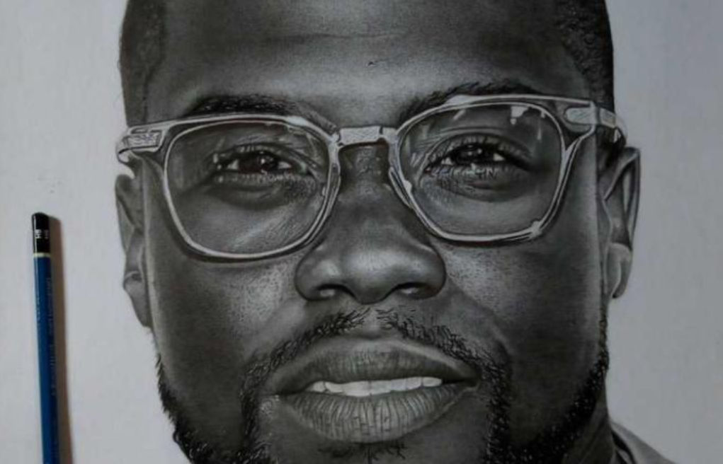
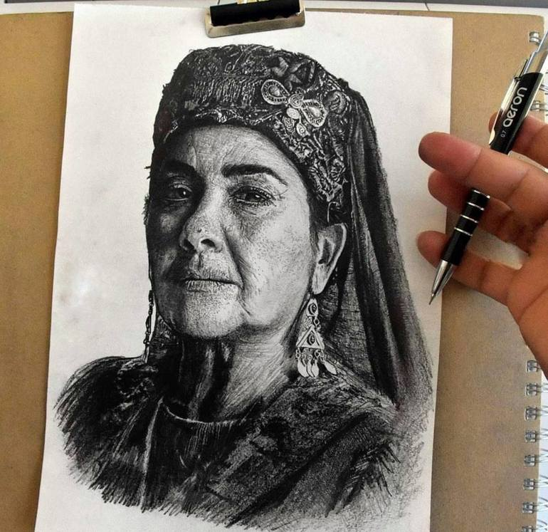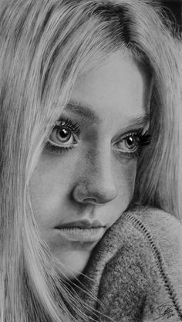
DUE DATE: SENIORS: WEDNESDAY, JUNE 10, 11:59 PM
GRADES 9-11: FRIDAY, JUNE 12, 11:59 PM

