Full Value Drawing
Studio Art 1
Now that you’ve had practice with shading and adding value to make your drawings look more three-dimensional, we’re going to take it up a notch and do a drawing where you have to do all the decision making yourself. The last couple of exercises you were following an artist and the artist made all the decisions—you just had to copy.
This next assignment I’m going to let you choose between two photos—both are the same level of difficulty. Each photo has definite dark grays, medium grays and light grays in the image, and what you’re trying to do is decide where to place these different tones of gray in your drawing as you’re shading.
I don’t expect perfection—most of you have never done this before. But I do expect that the entire paper has different tones of gray on it; there should NOT be large white spaces or a white background. I’ll put a few student examples below so you can see how the entire paper has different tones of gray:
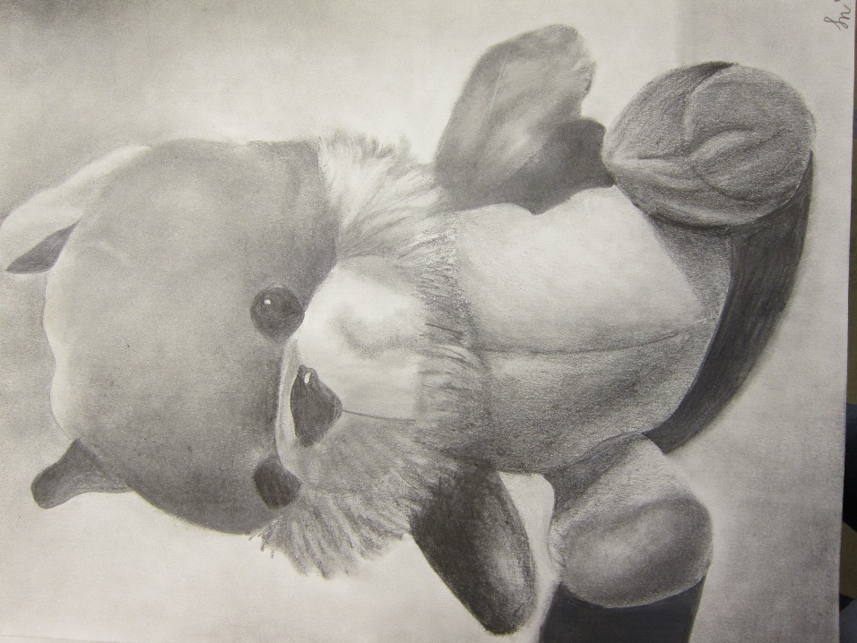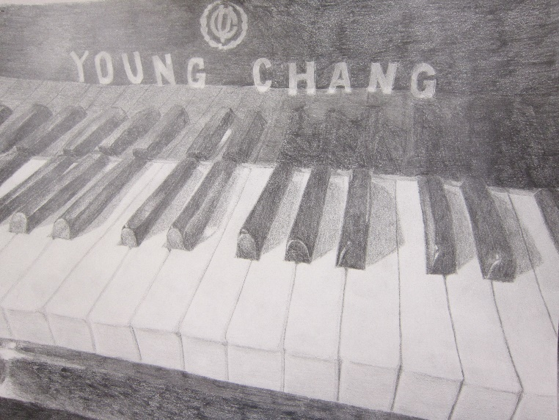
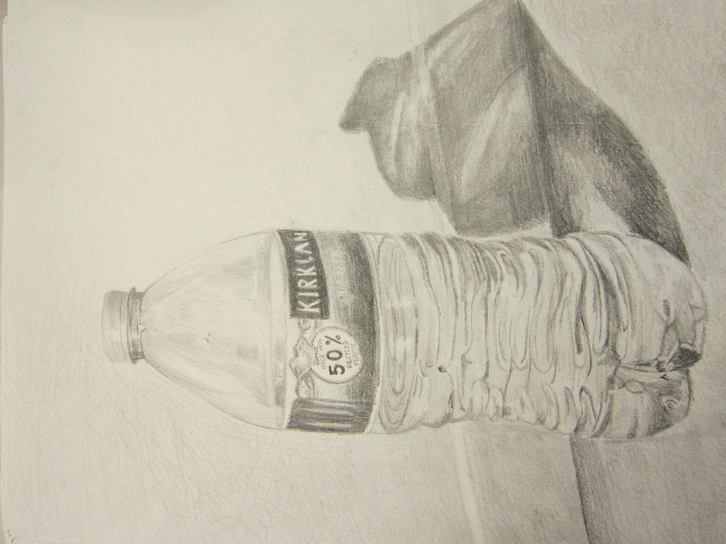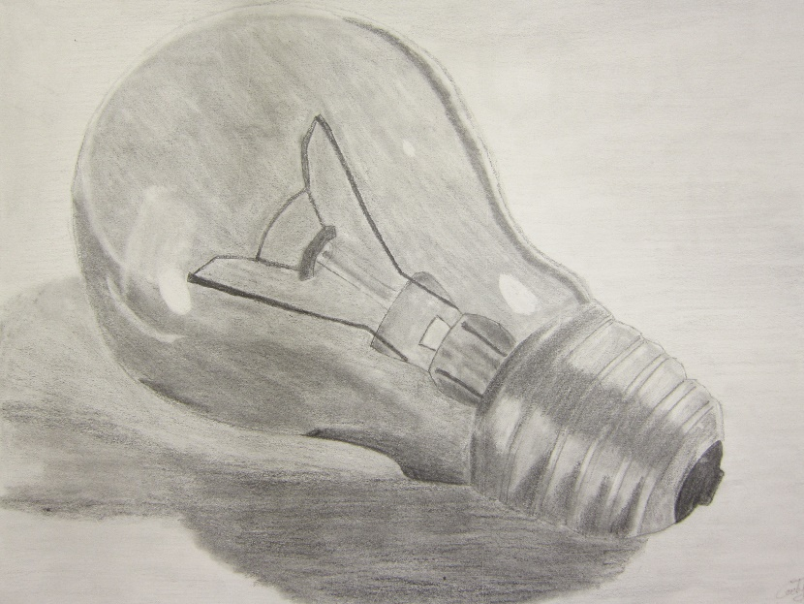

Pick one of the two photos of manikins that are at the end of this assignment. I took these photos specifically so that it is easier for a beginner to see the light and dark areas and the textures are smooth. If you can, print out the photo you want to use because it is always better to work from a printed copy of an image than a screen—that includes your phone. However, if you can’t print it out don’t worry, just do the best you can working from the screen.
Make sure that your drawing fills the entire paper, just like the student examples above.
I am giving you more time to work on this project because of the amount of time it takes to do this properly. Have fun!
DUE DATE: TUESDAY, MAY 12, 11:59 pm

