STIPPLING
Studio Art 2
This project will introduce you to a new technique called stippling, which is also called pointillism. Stippling is usually done in ink and is a method to produce value in an artwork.
The closer together the dots are, the darker the value. Here is a simple value scale (remember doing those?) using stippling:
STIPPLING TAKES A LONG TIME! So you must be patient as you do this project. Some of you will love it, others of you. . .well, maybe not so much. It’s OK, though, because this is a learning experience and I want you to try new art techniques.
So instead of shading with a pencil, you are going to use ink. It can be a ballpoint pen, or any type of felt-tip markers (like sharpies, prismacolor pens, etc.) You can draw everything lightly in pencil to make sure you get proportions correct, but in the end you will erase any pencil marks that show. EVERYTHING HAS TO BE DONE WITH DOTS. . .NO LINES.
You can choose to draw whatever you like. You can make up the picture completely from your imagination, or you can look up a photo of something and use it as a reference. The drawing needs to fill the page. You can use color ink if you have it, but black and white is perfectly fine, too. Below I’m going to show you a few examples of stippling. Keep in mind, these are professionals!:
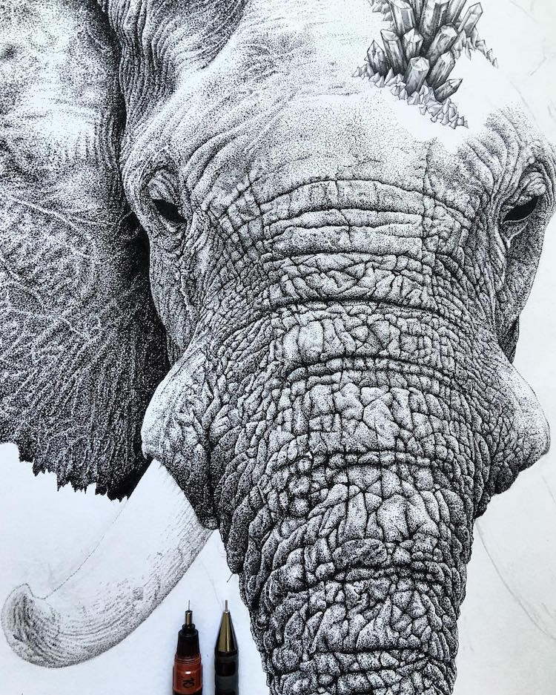
Nicholas Baker
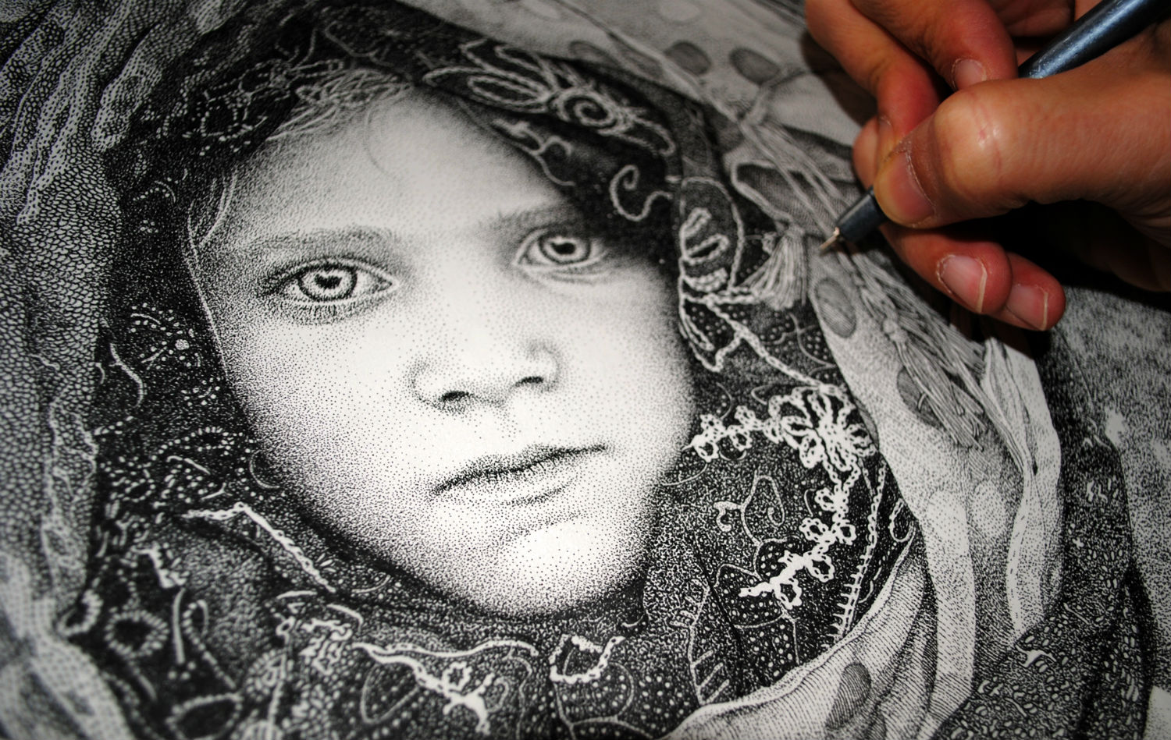
Pablo Jurado Ruiz

If you feel lost and would like to watch a tutorial, I will include a link here. THIS IS NOT MANDATORY, it is just to help those who would like more guidance:
https://www.youtube.com/watch?v=pE5JgjgOw7M

DUE DATE:
FOR SENIORS: WEDNESDAY, JUNE 10, 11:59 PM
FOR GRADES 9-11: FRIDAY, JUNE 12, 11:59 PM

