Window Drawing
Studio Art 2

Windows are an extremely symbolic object in art. They can symbolize growth, change, fear, and desire. Lucky for us, we all have windows where we live! So yes, this week we’re going to create artwork that uses a view from a window.
This is an observational drawing, which means that you MUST be looking at the window and other objects and drawing them as realistically as possible. And no, you cannot have a sky full of clouds or a blank sky. . .that won’t cut it.
Also, if you are using pencil, you MUST have a FULL VALUE SCALE to receive full points. That means you must shade the entire page and have dark, medium and light gray tones to form the objects. You are all advanced students so I expect more from you.
I will include some examples below; however, these examples only demonstrate option #1 of your two options for drawing. Here are your choices:
Option #1 | Option #2
Draw what you see out the window | Create something completely different than what you see out the window
This means that you continue your observational drawing and draw exactly what you see outside. | This means you can create whatever you want outside your window. You could have unicorns, a giant mouse, Justin Beber, etc. Use your imagination. It must be realistic, which means you may have to find reference photos to look at.

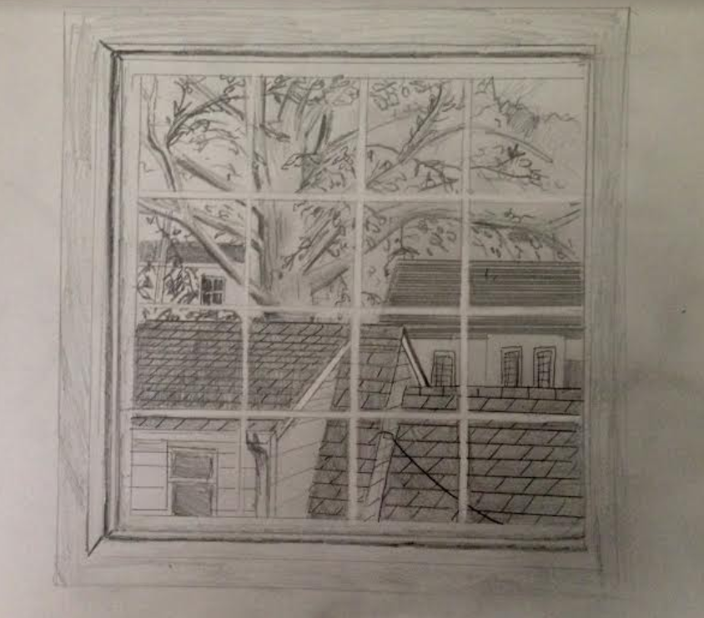
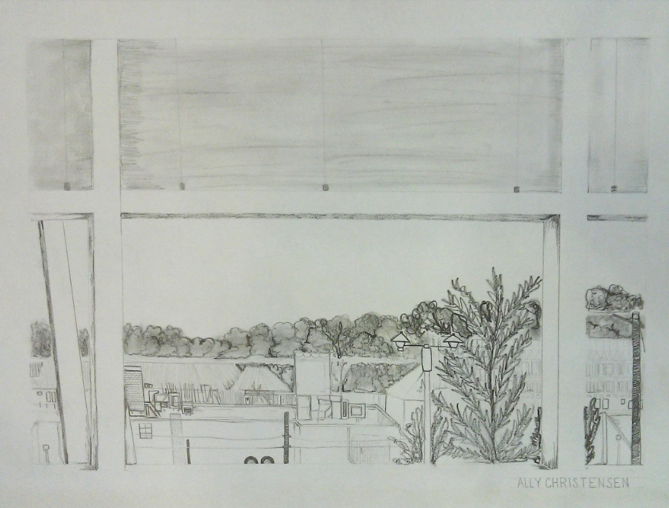

DUE DATE: TUESDAY, MAY 12, 11:59 pm

